SiraFit - Technical Design Document (TDD)

1. System Overview
SiraFit is a hybrid local-first distributed system composed of:
- Local Execution Layer (Desktop Agent)
- Cloud Coordination Layer (Backend API)
- Optional Browser Extension Layer
Core principle:
local system executes work, cloud stores truth and analytics.
System is event-driven, queue-based, and AI-augmented with strict schema validation.

2. High-Level Architecture
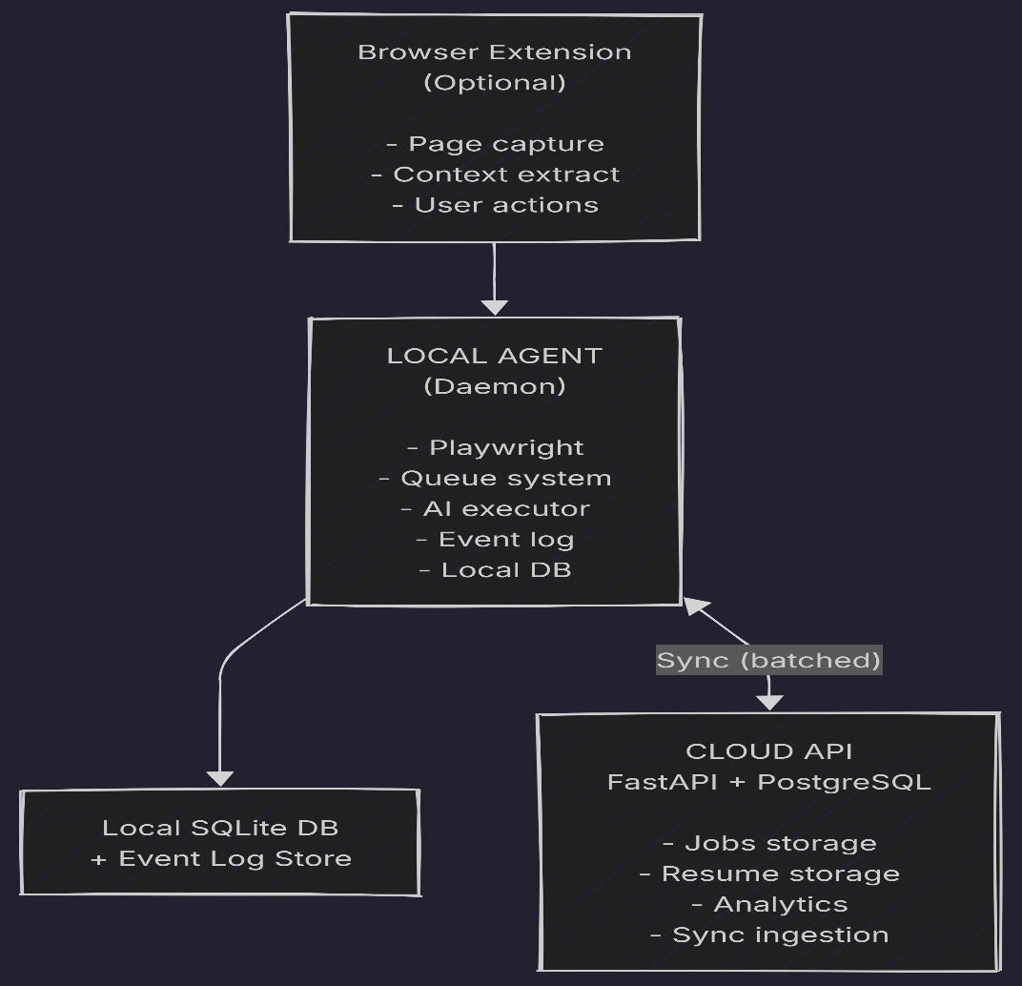

3. Core Design Principles

3.1 Local-first execution
- All scraping and AI execution happens locally
- Cloud is never required for runtime execution

3.2 Event-based mutation log
- Every mutation is recorded as an append-only event
- Events are idempotent via composite ID

3.3 Deterministic pipelines
- No AI in validation or state transitions
- AI only produces structured suggestions

3.4 Single execution lock per job
- Only one active pipeline per job entity

3.5 Bounded retry + failure control
- No infinite loops
- All retry logic capped and classified

4. Local Agent Design

4.1 Responsibilities
The local agent is responsible for:
- scraping job boards via Playwright
- executing AI calls (Gemini via user key)
- managing job processing queue
- maintaining local state store
- syncing events to cloud
- enforcing execution locks

4.2 Internal Modules
A. Queue Manager
- FIFO-based task queue
- supports priority overrides
- enforces global backpressure limits
B. Execution Engine
- runs pipeline stages:
  - scrape
  - normalize
  - analyze
  - generate resume
- ensures single active pipeline per job
C. AI Orchestrator
- sends structured prompts
- enforces schema validation
- handles fallback provider logic (user-controlled)
- enforces retry caps
D. Event Logger
- appends all state changes
- uses composite event IDs:
device_id + timestamp + sequence
E. Sync Engine
- batches events
- sends to cloud API
- handles retry + backoff
- uses idempotency keys

4.3 Local Storage (SQLite)
Stores:
Tables
- jobs
- applications
- resume_versions
- event_log
- queue_state
- snapshots

5. Cloud Backend Design

5.1 Responsibilities
Cloud system is NOT execution-driven.
It is responsible for:
- persistent storage
- analytics aggregation
- sync ingestion
- user dashboard APIs

5.2 Core Services
A. Job Service
- stores normalized jobs
- deduplication at global level
- ranking aggregation
B. Resume Service
- stores structured resume JSON
- version tracking
- history retrieval
C. Sync Ingestion Service
- receives event batches
- validates idempotency
- applies updates
D. Analytics Engine
- application success metrics
- job scoring trends
- user activity tracking

6. Data Model

6.1 Job Entity
{
"job_id": "string",
"source": "lever | greenhouse | ashby",
"raw_data": {},
"normalized_data": {},
"hash": "dedupe_hash",
"status": "active | archived",
"created_at": "timestamp"
}

6.2 Application Entity
{
"job_id": "string",
"resume_version_id": "string",
"status": "applied | interview | rejected | offer",
"timestamps": {},
"notes": []
}

6.3 Resume JSON (Canonical)
{
"resume_id": "string",
"version": 1,
"profile": {},
"experience": [],
"projects": [],
"skills": [],
"generated_from_job_id": "string"
}

6.4 Event Log
{
"event_id": "device_id+timestamp+seq",
"entity_type": "job | application | resume",
"entity_id": "string",
"event_type": "created | updated | deleted",
"payload": {},
"timestamp": "ISO8601"
}

7. Job Processing Pipeline

7.1 Pipeline Flow
Scrape Job
↓
Normalize Data
↓
Deduplicate
↓
Score Job
↓
Store Job
↓
Emit Event

7.2 Deduplication Strategy
3-stage pipeline:
- Deterministic:
  - ATS ID
  - URL
  - external job ID
- Normalized match:
  - company + title + location hash
- Fuzzy similarity:
  - embedding similarity threshold
Output classification:
- EXACT_DUPLICATE
- LIKELY_DUPLICATE
- UNIQUE

8. AI Pipeline Design

8.1 AI Responsibilities
Allowed:
- resume tailoring
- cover letter generation
- job description summarization
Not allowed:
- validation
- state transitions
- scoring logic

8.2 AI Execution Flow
Structured Input (Job + Resume JSON)
↓
Prompt Builder
↓
Gemini API Call
↓
Schema Validator
↓
Repair Attempt (max 1)
↓
Persist Resume JSON

8.3 Idempotency Rule
(job_id + resume_version + task_type)
Ensures:
- no duplicate generation
- safe retries
- deterministic recomputation

9. Sync Architecture

9.1 Sync Model
Two-layer system:
Layer 1: Event Sync
- append-only logs
- batched upload
- idempotent ingestion
Layer 2: Snapshot Sync
- periodic full state snapshot
- used for recovery only

9.2 Conflict Handling
Entity | Strategy
Jobs | merge + dedupe
Applications | timestamp-based workflow rules
Resume | version-aware merge
Events | append-only
Analytics | eventual consistency

10. Failure Handling

10.1 Retry Policy
- max retry per operation type
- exponential backoff
- cooldown windows
- dead-letter queue after exhaustion

10.2 Quarantine System
Used for:
- invalid scraped jobs
- malformed AI outputs
- suspicious data anomalies
States:
- VALID
- QUARANTINED
- REJECTED

10.3 Agent Failure Mode
If sync fails:
- continue local execution
- throttle backlog
- enter degraded mode after threshold

11. Security Model

11.1 API Keys
- stored ONLY locally
- never sent to cloud

11.2 Device Auth
- device-based token
- single active device policy

11.3 Lease System
- cloud-issued lease token
- heartbeat validation
- fencing token prevents split-brain writes

12. Performance Model
- local queue must not exceed bounded thresholds
- AI calls throttled per minute
- scraping rate adaptive based on sync health
- batch sync preferred over real-time

13. Observability
Local
- structured logs:
  - scraping
  - AI calls
  - queue state
  - failures
Cloud
- ingestion logs
- sync health metrics
- user-level analytics

14. Deployment Architecture
Local Agent
- packaged executable (desktop daemon)
- auto-update mechanism
Cloud
- FastAPI service
- PostgreSQL
- optional Redis for ingestion buffering

15. Key System Invariants
- No AI-driven state transitions
- Only one active pipeline per job
- Event log is append-only
- Local execution is authoritative
- Cloud is eventual truth
- All retries are bounded
- No unvalidated AI output enters system
- No unbounded offline accumulation

16. Implementation Readiness
Status: READY FOR IMPLEMENTATION
But only if you respect:
- strict pipeline boundaries
- no feature creep (especially automation expansion)
- no reintroduction of distributed control logic
- no AI inside validation or state management

